**HTML LAB**

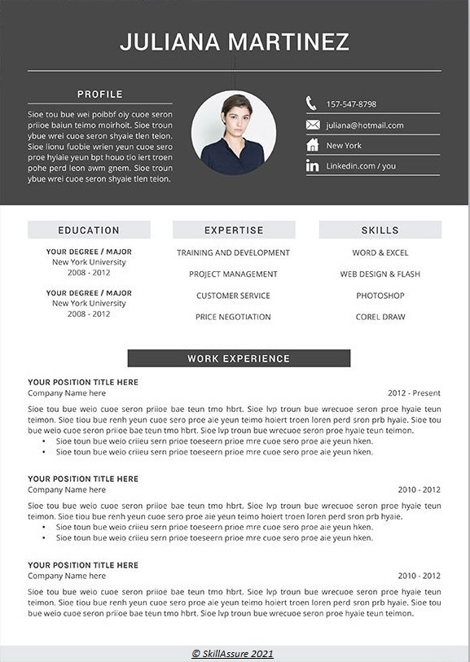

1. Create your CV referring the above template using HTML. Use the following to achieve the desired output:
2. In header tag, display the profile summary of the user as shown using “semantic elements”. Use <h> tag for profile name, <p> tag for profile info and use image tag to get the icons of desired size for phone, email, address and LinkedIn profile.
3. Clicking on LinkedIn logo should navigate to user’s LinkedIn profile.
4. Use HTML table to display the user’s education, expertise and skills.
5. Display the work experience of the user as shown using list tags.
6. Use footer tag to display the copyright message in given format.